**The application of optimization techniques to explore free throw performance**

J. Mortensen[1] and J. Porter[2]

Brigham Young University, Provo, UT, 84604

# Abstract

Arm motion has been diversely studied in the field of biomechanics. The resources and technology available for studying the motions of the body in sport related activities have been used to benefit athletes. The role of optimization has been used in the past to improve athletic form. Computer simulations imitate the mechanics of the body to provide realistic explanations as to why certain motions carry out better performance. However, optimization can also be used as a tool to understand how a player must practice in order to obtain control and reliability during performance. This study was comprised of two optimization analyses to determine the best approach to shooting a free throw. Based on the average height statistics of NBA players in 2015, the optimal path of the arm was determined based on the most reliable trajectory of the ball to score a foul shot. Because of the complexity of the arm, simulating the skeletal and muscular structures of the arm were simplified in a 3-dimensional model. Muscular activity was incorporated in the design in order to provide an analytical perspective of reliability of a shot contrasted with repeatability. Preliminary results suggested that the traditional free throw shot was likely the most optimal method. However, further development of the project will incorporate an improved model of the arm and introduce muscular fatigue to better simulate motion repeatability.

# Introduction

C

orrectly performing a free throw in the game of basketball requires a complex motion by an athlete. In order to be successful free throw shooters, athletes need to perform their shooting motion in a way that can be repeated consistently many times. This project seeks to mathematically explore whether or not the accepted “perfect form” for free throw shooting is optimal way to shoot a free throw.

The accepted perfect free throw was characterized by Tran in 2008. This study used computer models to get a numerical description of the perfect free throw. For a player that is 6 feet 6 inches tall, a release angle of 52 degrees and a peak height of 12.4 inches. Figure 1 is an illustration that describes the perfect free throw. This study is meant to search free throw form in a broader and simpler manner to either confirm these results or point towards a different form.

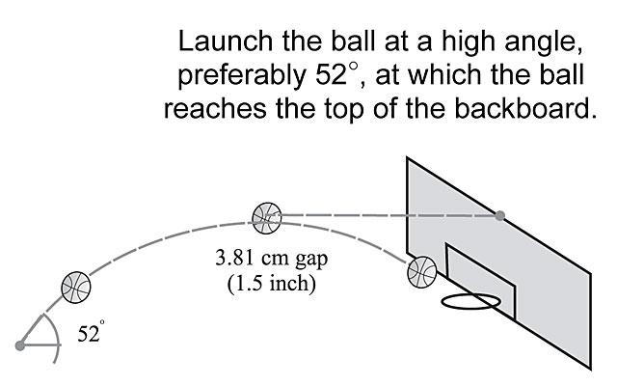

**Figure 1. Illustration of currently accepted perfect freethrow release**

The most efficient motion path may be in a variety of forms and will be one that takes advantage of the momentum applied in the shooting direction. For instance, a “Granny-shot” could produce an optimal shot. However, the hypothesis of this study is to see if the traditional method of shooting a free throw is the most optimal when considering reliability.

This study was limited to the motion of one arm performing a free throw shot. The arm was modeled as a rudimentary skeletal structure of the upper arm and forearm with muscular interaction. All arm properties were based on relative proportions based on the average height and weight of an NBA basketball player in 2015. Simplistic kinematic equations were used to derive the shooting path of the ball upon release. Constraints were enabled to prevent the simulation of joint hyperextension and muscle overloading. Optimization was performed on MatLab using a Quasi-Newton Method and a Genetic Algorithm.

The concept of optimizing a free throw shot can be advantageous in a variety of different sports. If an athlete can understand the physical motions required for optimal performance, he will know exactly what to practice in order to master his sport with greater motion control and consistency.

# Methodology

To achieve the results of this study, two separate optimization problems were solved. The first was focused solely on the basketball’s motion starting at the point the ball is released by the shooter. Optimization techniques were used to find the best release point and release velocity of the basketball in terms of reliably making the shot. The second optimization problem involved calculating the motion of the human arm that would most efficiently get the basketball to the initially position and velocity calculated from the first optimization problem. This second problem relies on the assumption that the arm motion that minimizes the change of momentum of the ball during the shot provides the optimal solution.

1. **Reliable Projectile Path**

The optimization problem involving the kinematics of the basketball itself will be addressed first. Projectile displacement equations were used to develop a function that if supplied an initial position and initial velocity will calculate how close the basketball would be to making a shot. Essentially the function assumes the input velocity has a large enough vertical (Y) component to it to get the basketball higher than the rim and then calculates where the ball is in the X and Z coordinates when the ball passes through the height of the rim (10 feet).

The function incorporates a simple Monte Carlo simulation to introduce human error into the system. The function runs through the calculations required to determine how close the shot is to being successful 100 times or more while treating the input variables as a normal distribution. The mean distance from making a shot is then used for the objective function in this optimization problem. This allows the optimizer to solve for the motion that is the most likely to consistently make free throws. The normal distributions for the input variables assumed standard deviations of 1 ft/sec for initial velocity and 1 inch for initial position.

To avoid local minimums being found, one more assumption was used. This is that the optimal solution would minimize the initial velocity as well, because the human body has less and less control the faster it moves. To account for this, a penalty of 5% of the norm of the initial velocity was added to the objective function.

To actually solve this problem the genetic algorithm MATLAB function, “ga” was used. A genetic algorithm was selected so that a global minimum would be found, instead of one of the many local minima associated with this problem. Bounds were set for initial position using the proportionality factors and the average height of a NBA player. The bounds ensure that the ball cannot be released from anywhere that an average NBA player could not reach. Bounds were set on the initial velocity to ensure that the basketball would get higher than the rim and that the ball would not be released at speeds higher than 50 ft/sec. No constraints were needed for this problem that could not be met by upper and lower bounds, and all the default options were used for the genetic algorithm.

1. **Optimal Arm Motion**

A simulation of the basic arm components was developed order to provide a realistic representation of the arm's response to movement. The model was composed of skeletal and muscular components which mimicked the time step response of an arm put into motion. For simplification purposes, the scope of the arm was limited to the upper arm and forearm. Acting as joints, the shoulder, elbow, and hand were connected by skeletal links. The muscle groups responsible for arm motion were attached at the tendon locations relative to each joint.

The model of the arm was designed based on the proportions of an average sized NBA player in 2015, staging the height to be 6'9" (site this). Though body proportions vary from person to person, they provided a model that represents that represents an average person. Individual analyses can also be determined for individual purposes.

The model was used to stage a n-frame motion of the arm performing a free throw within a sub-second timeframe. Based on the results of the trajectory analysis of the ball, the arm motion path was produced to take advantage of momentum in order to produce a shot matching the trajectory of the ball described by the kinematic optimization.

min |m2 - m1|

s.t. c = theta elbow < 18 etc.

Optimization process...

In order to analyse the data produced by the optimum model, rotational energy about the joints were taken into account. Information on muscle activity was gathered and presented information related to consumption of energy. However, this information is inconclusive.

# Results

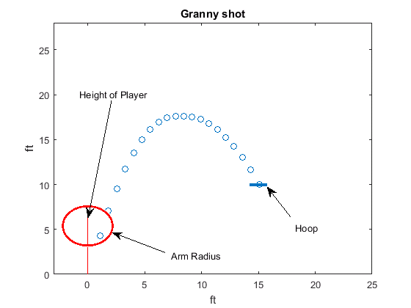a When the first optimization problem (basketball motion from release point on) was solved without attempting to minimize velocity, a shot that looks similar to a “granny shot” was obtained. This type of shot is an underhand shot, and is not usually used for shooting free throws. This result suggests that the optimal solution if projectile motion is the only consideration is a granny shot. Figure 2 shows this result. The blue circles represent the path of the ball. Red circle represents the maximum distance the player can reach. The vertical red line represents a basketball player, with the top of the line indicating the overall height of the player.

**Figure 2. Granny style shot solution obtained with no attempt to minimize velocity**

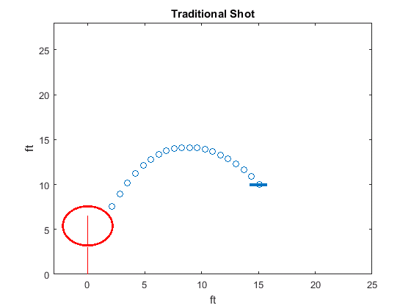When minimizing initial velocity was included in the objective function, the results changed drastically to look a lot more like a regular basketball shot. The ball being released as far as a player can reach and at an upward angle is what players in the NBA currently do. According toTran, the best way to shoot a basketball is with a release that has a 52 degree angle from the horizontal. The solution solved for by MATLAB has a release angle of 51.99 degrees. The perfect height is supposed to be 12.4 ft, and a peak height of 12.4ft was calculated.

# Discussion

The results from this study are very similar to what is accepted as perfect form. The release angle and position match the study that Tran did eight years ago, and the arm movement portion of this study match what is accepted as perfect form in the NBA today.

The motion this study calculated to be the optimal free throw form is close enough to what accepted perfect form looks like to reach a reasonable conclusion that the accepted perfect form close to optimal. However, the motions don’t match perfectly. Further work is needed to build higher fidelity models to find the truly optimum free throw motion. This model only accounts for the arm motion of a player. Basketball players usually bend their knees when shooting, in order to get some upward motion when they release the ball. The model developed for this study does not account for the wrist joint or any forces developing in the hand. The model could also be improved to account for the effect of spin on the basketball. Another way that this model could be improved is to link the kinematics of the ball with the motions of the player. This would allow for the objective function to include the repeatability of motions, not just releases.

**Figure 3. Solution for shot style that matches the accepted perfect form**

Even with the limitations of this study, the results are enough to support the current form of free throw shooting as optimal. This study could be used to teach developing athletes more about the physics of shooting a free throw. The fact that optimization techniques agree with basketball experience, should make it easy to decide the kind of form an athlete should try to obtain in free throw shooting. If a basketball player decides a granny shot is the best form for them, or any form of shot that releases the ball fairly low, their decisions flies in the face of basketball experience and the science of optimization.

The authors hope that the concepts used in this study will be used as a starting point for gaining an understanding of the optimal motions used in sports. This study shows what the best way to shoot a free throw looks like, and points to reasons why. This understanding will help basketball players. If the concepts from this study are used for other sports, more athletes could benefit from understanding the science of their sport. Also, better techniques may be developed as more sport motions are examined.

# Conclusion

The intent of this study was explore whether or not the currently accepted perfect form for free throw shooting is also the optimal form for free throw shooting. Two optimization problems were solved for this study. The first was a problem based on the kinematics of a basketball from the point of release forward. The problem was solved and results agree with past research, in that the optimal release angle is 52 degrees and the peak height of the basketball should be approximately 12.4 ft. The second optimization problem that was solved involved finding the optimal motion that would result in a velocity and release angle that was solved for in the first optimization problem. This second problem was solved using an assumption that the optimal motion would be the motion that requires the least change in momentum of the basketball. The results of solving this problem closely agree with the accepted perfect form. Reasons for small differences in this solution were explored, and further work in this area of study was proposed. The results of this study support that the currently accepted form for free throw shooting is also the optimal way to shoot a free throw.

# References

The Anatomy of a Free Throw. (2012). Retrieved April 11, 2016, from http://www.popularmechanics.com/adventure/ sports/a7552/basketball-physics-the-anatomy-of-the-free-throw-7556633/

Tran, C. M., & Silverberg, L. M. (2008). Optimal release conditions for the free throw in men's basketball. Journal of Sports Sciences, 26(11), 1147-1155. doi:10.1080/02640410802004948

King, T. (1987). OPTIMIZATION OF BASKETBALL FOUL SHOT TECHNIQUE. American Society of Mechanical Engineers, Design Engineering Division.

Chen, J. (2014). Biomechanics Analysis of Shooting in Basketball. AMM Applied Mechanics and Materials, 685, 477-480. doi:10.4028/www.scientific.net/amm.685.477

Covaci, A., & Talaba, D. (2013). Correlations in Basketball Free Throw. AMM Applied Mechanics and Materials, 332, 509-514. doi:10.4028/www.scientific.net/amm.332.509

Tian, S. (2014). Biomechanical optimization model-based basketball field-goal percentage influence factors study. BioTechnology: An Indian Journal.

Giroux, C., Rabita, G., Chollet, D., & Guilhem, G. (2016). Optimal Balance Between Force and Velocity Differs Among World-Class Athletes. JAB Journal of Applied Biomechanics, 32(1), 59-68. doi:10.1123/jab.2015-0070

Stambolian, D., Eltoukhy, M., & Asfour, S. (2016). Development and validation of a three dimensional dynamic biomechanical lifting model for lower back evaluation for careful box placement. International Journal of Industrial Ergonomics, 54, 10-18. doi:10.1016/j.ergon.2015.12.005

Li, N., Wu, S., Wang, W., & Ye, B. (2014). Anisometry Anterior Cruciate Ligament Sport Injury Mechanism Study: A Finite Element Model with Optimization Method. AMM Applied Mechanics and Materials, 543-547, 173-180. doi:10.4028/www.scientific.net/amm.543-547.173

Bray-Miners, J., Runciman, R. J., & Groendyk, N. (2014). Methods and instrumentation for the biomechanical analysis of slalom water skiing. Proceedings of the Institution of Mechanical Engineers, Part P: Journal of Sports Engineering and Technology, 228(2), 75-85. doi:10.1177/1754337113520150

Huchez, A., Haering, D., Holvoët, P., Barbier, F., & Begon, M. (2013). Local versus global optimal sports techniques in a group of athletes. Computer Methods in Biomechanics and Biomedical Engineering, 18(8), 829-838. doi:10.1080/10255842.2013.849341

1. Mechanical Engineering Student, jon.mortensen12@gmail.com
2. Mechanical Engineering Student, jasonsporter88@gmail.com